ISOS early help research: presentation of final report ahead of 19 March launch

Purpose of report
For discussion.

Summary
In July 2018 the Local Government Association commissioned Isos Partnership to undertake research to explore the enablers of and barriers to developing and sustaining an effective local early help offer. The following papers include the key findings and executive summary of the research, the final report of which will be formally launched at an event in 18 Smith Square on 19 March. Natalie Parish, Isos Partnership, will attend the Board meeting to lead a discussion of the report’s findings.

Recommendation and action
That the Board discuss and comment on the report’s key finding and executive summary.

Contact officer: Ian Dean
Position: Senior Adviser, Children’s Social Care
Phone no: 0207 665 3878
Email: ian.dean@local.gov.uk

Early Help research final report
Key findings
In July 2018 the Local Government Association commissioned Isos Partnership to undertake research to explore the enablers of and barriers to developing and sustaining an effective local early help offer. The findings of this research are based on in-depth engagement with eight local areas, which were selected because they were known to have continued to invest in the development of local early help offers and were doing interesting and innovative things with that investment. In constructing the sample, we also aimed to achieve a balance in key contextual variables such as size, rurality, deprivation and funding. This report explores in detail how these local areas had constructed their early help offers; how these had evolved over time; the key enablers that had supported the creation of an effective offer; and the future challenges that local areas were addressing.
Each of the local areas had taken their own distinctive approach to developing their early help offer, based on the needs of their populations and the history of how early intervention had previously been delivered in the locality. However, despite these differences there were some clear similarities between the eight areas, both in terms of organisation and principles.
Similarities in the organisational structure of ‘early help’

In terms of their organisational structure, all eight of the local areas engaged in the research had a ‘key work’ support service for families. This was typically delivered by a multi-disciplinary team and tended to be targeted towards families exhibiting relatively higher levels and complexity of need. All the local authorities also supported statutory partners, including schools and early years providers, health and the police, to act as lead professionals for families requiring early help. Finally, all eight local authorities also had an underpinning offer of universal or group-based support offered either by the community or through community-based local authority run hubs such as children’s centres.
In describing the principles that underpinned their approach to early help, all eight areas displayed a remarkable degree of similarity. There were four themes that recurred consistently: The earliness of early help; working with families; building resilience; and an integrated joined-up offer.
The research found that a hallmark of an effective early help offer is that it is continually evolving. The local areas engaged in the research had developed their early help offers in an iterative way, with four quite distinct and mutually supporting phases:
The evolution of a local early help offer
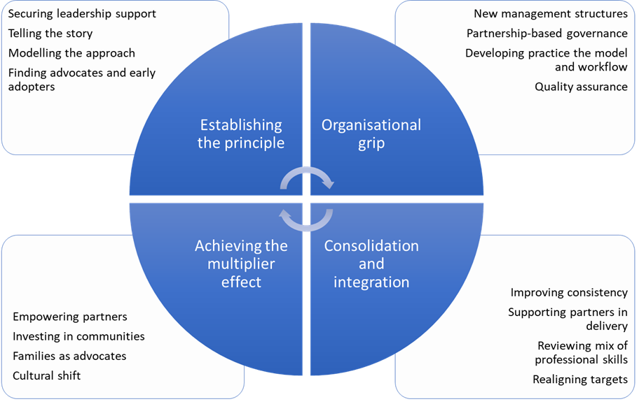
Local authorities spoke about the importance of establishing support for the principle of early help within their own leadership cadre and with key advocates and catalysts in their partner agencies. This was then reinforced by exerting an organisational grip - putting in place the building blocks that would ensure early help was delivered consistently. The third phase of development – consolidation and integration – enabled local areas to improve consistency through better integration across a wider range of partners and experimenting with different ways of supporting partners in their delivery of early help. The fourth phase of development could be described as looking to achieve a ‘multiplier effect’. This is the point at which early help genuinely becomes ‘everyone’s business’.
For local authorities and their partners navigating the ongoing development of a strategic early help offer, the research identified sixteen key enablers which fit within four main dimensions. These are represented graphically below:
The key enablers
- 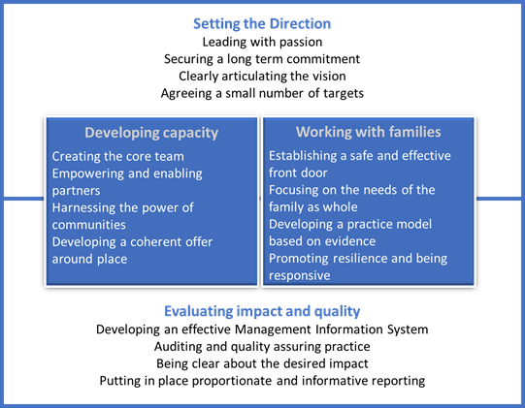
Going forward, the role of early help in supporting children and families is likely to be front and centre in discussions at local level about where scarce and valuable resources should be allocated. To maximise the potential of early help, local authorities and their partners will need to strike the right balance between investing in long-term goals and achieving shorter-term reductions in demand for statutory services; explore how intensive and more universal forms of early help can complement each other most effectively; become sharper in both responding to demand and predicting need; resolve the tension between widening and deepening the scope of integration; and develop system-level responses to new types of need and risk.
Local areas suggested that in order to navigate the future effectively, and address some of the questions posed above, they would benefit from additional tools to help them to assess the impact and value for money of early help and to have better oversight of the strategies that local areas have deployed in developing their early help offers. We have therefore used the content of this research to develop thinking around these two areas. We have developed a working proposition for a balanced scorecard that includes very simple metrics relating to relative early help expenditure; the impact on demand for statutory services; and the impact on long-term well-being. We have also suggested a framework that sets out for local authorities the evidence base on how to approach the different phases of establishing an early help offer, organised according to the sixteen key enablers.

Executive Summary
What is early help?
- The history of the development of early help in England has been rooted in local discretion. It is therefore not surprising that the early help offers, in the eight local areas engaged in this research, have evolved in quite different ways. Nonetheless, there are some clear similarities between the eight areas, which together help to create a definition of what is meant by a local partnership-based early help offer.
- In terms of their organisational structure, all eight of the local areas engaged in the research had a ‘key work’ support service for families. This was typically delivered by a multi-disciplinary team and tended to be targeted towards families exhibiting relatively higher levels and complexity of need. All the local authorities also supported statutory partners, including schools and early years providers, health and the police, to act as lead professionals for families requiring early help. These families would often be supported in a similar way to those receiving a targeted key work service, but the focus of the lead professional would be more around integrating the support they could provide within the parameters of their professional role and expertise, drawing in additional support where that was needed. Finally, all eight local authorities also had an underpinning offer of universal or group-based support offered either by the community or through community-based local authority run hubs such as children’s centres. The flow of individual families into and out of these wider supporting networks tended to be less closely tracked and often corresponded with families whose needs were less complex or were more able to make a sustain progress independently.
- In describing the principles that underpinned their approach to early help, all eight areas displayed a remarkable degree of similarity. There were four themes that recurred consistently: The earliness of early help; working with families; building resilience; and an integrated joined-up offer. This common ground, particularly in terms of the underlying principles and goals, to construct a definition of an effective local early help offer. The working definition that we developed for the purpose of this research is:
- An effective early help offer brings together local partners to provide good quality early support for children and families that builds their resilience, prevents difficulties from escalating and leads to better outcomes that are sustained.
The Lifecyle of developing early help
- All eight local areas which took part in this research were in the process of refining, refocusing or even redeveloping their offers of early help. Indeed, a hallmark of an effective early help offer is that it is continually evolving. Despite the differences in context, and in the organisational solutions put in place, there were four critical phases in the development of a local early help offer. These four distinct phases are not linear. Many of the local areas engaged described an iterative process, so it is more accurate, therefore, to think about the phases of developing an early help offer as a layered process with each successive development building and refining what has preceded it, rather than replacing it.
- Local authorities spoke about initially establishing support for the principle of early help within their own leadership cadre and with key advocates and catalysts in their partner agencies. In the second phase of development they looked to exert an organisational grip - putting in place the building blocks that would ensure early help was delivered consistently. The third phase of development – consolidation and integration - often came after the early help offer had been in place for a couple of years, at which point local areas could assess the impact of what they were doing, look at how they could improve consistency through better integration across a wider range of partners and experiment with different ways of supporting partners in their delivery of early help. The fourth phase of development could be described as looking to achieve a ‘multiplier effect’. This is the point at which early help genuinely becomes ‘everyone’s business’ and early intervention becomes the dominant way of thinking about public service delivery.
The key enablers of developing an early help offer
- There was a relatively high degree of consensus among leaders and staff in the eight fieldwork areas about the key enablers of developing an effective and partnership-based early help offer. Through this research we identified sixteen key enablers which fit within four main dimensions. These are represented graphically below:

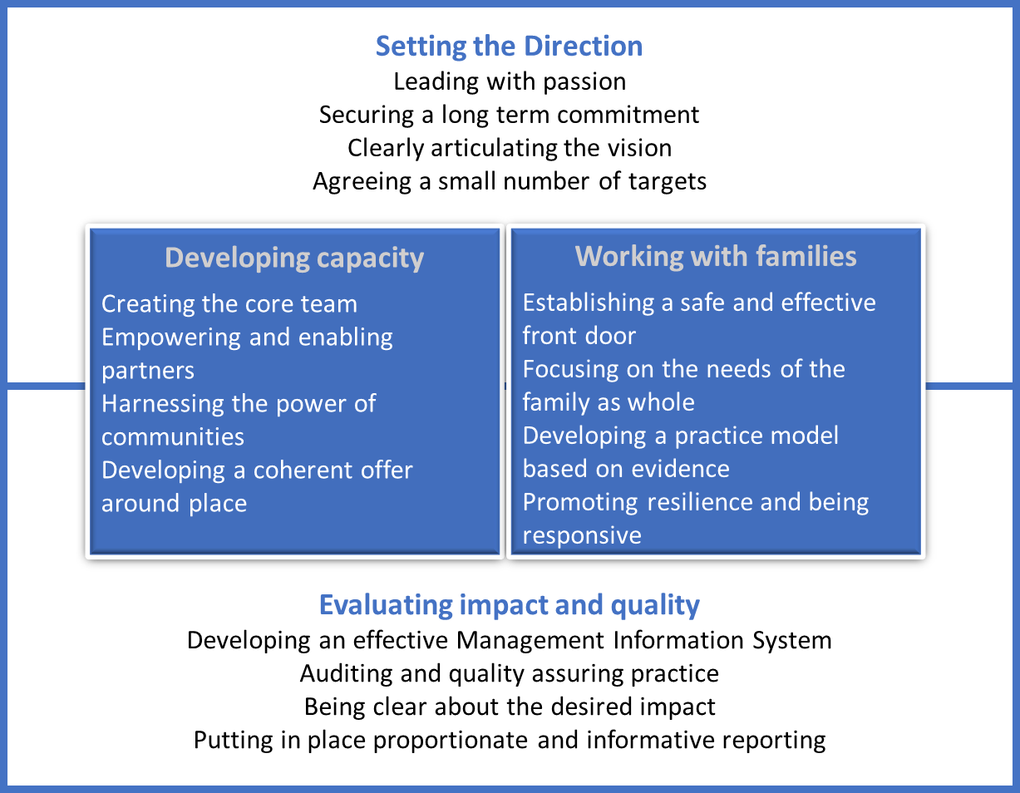

Setting the direction
- In setting the direction for early help, the first key enabler was leading with passion. Leaders in those local areas where early help was most embedded, and most effective, all demonstrated a strong conviction in the power of early help. Local areas fostered this sense of conviction and belief through, amongst other strategies, the power of story-telling and creating a clear narrative; leveraging dissatisfaction with outcomes achieved by traditional ways of working; and making judicious use of the evidence base for early intervention. A further hallmark of leaders who were passionately committed to the concept of early help is that they were prepared to take organisational risks, or pursue creative and sometimes untried approaches, in order to deliver a more effective approach to early help. The final element was the extent to which the concept of early help had permeated the culture of the local authority, and its partners. In those areas where the early help offer appeared to be strongest there was a sense that early help was not simply another service, or indeed a collection of services under a new banner. Rather the principles of early help permeated every interaction between the local authority or their partners and residents.
- Developing an effective early help offer requires not just passion but also a long-term commitment. In most of the local areas included in the research the political commitment to having in place an effective early help offer had not been limited by the time frame of electoral cycles. The long-term nature of the commitment to developing effective early help had also importantly translated into continued funding. Although all the local authorities involved in the research were beset with the same budgetary pressures facing children’s social care and other statutory services as have been widely reported nationally, together with their partners they had managed to sustain a significant level of funding in early help. One of the key risks to securing a long-term commitment to early help was the rapid turn-over of staff at all levels in children’s services. Local areas counteracted this risk of fragility through establishing strong governance mechanisms that supported partnership working and could cement relationships, plans and responsibilities beyond the tenure of key individuals.
- Clearly articulating the vision for why early help matters was an important step in setting the overall direction. Those local areas which had developed the most compelling visions were clear that early help was an ‘offer’ and not a ‘service’; were grounded in the principle of providing the right support for families at the right time; and could clearly articulate that early help is everyone’s business. A challenge for those setting the direction for early help in a local area is the risk that the offer becomes too diffuse and too complicated. Local areas that had successfully countered this risk had spent time up front in developing a very clear vision that was easy to understand and easy to communicate. Importantly, this vision statement was owned by partners and by staff, in many cases as a result of co-development. Local areas had worked on different ways to communicate their vision to ensure that it inspired and empowered professionals, and also so that it was accessible to children and families.
- Sitting alongside the vision for early help, a key element of setting the strategic direction was agreeing a small number of priorities which can be reflected in meaningful outcomes-based targets and using these as a way to track the impact of early help. Ideally these priorities and targets would link directly to key objectives within the corporate plan, placing early help at the centre of the organisation rather than on a limb. Some local areas could explain how a ‘golden thread’ linked the outcomes to which they were committed in early help with the broader local ambitions for community and place. Defining the priorities and outcome focused targets to guide the early help offer was in fact an area which many of the fieldwork local authorities recognised as a challenge. There was an inherent tension in some areas between developing a set of priorities that were strongly influenced by community and staff in a genuinely ‘bottom-up’ driven model and ensuring that this was informed by a rigorous and forensic analysis of what the most pressing needs are in a ‘top-down’ way.
Developing the capacity
- The second dimension of building an effective early help offer was developing the capacity within the local authority, with partners and in communities and families to provide effective early help. The four key enablers which support this dimension are creating the core team, empowering and enabling partners, harnessing the power of communities, and developing a coherent offer around place.
- All the local areas that we visited as part of the research had created a core service, managed by the local authority, that delivered intensive early help interventions on a key-worker model. One of the striking features was the range of different teams and professional disciplines that had been brought together into an integrated key worker service. To achieve this successfully local areas invested in training staff to create a shared culture and way of working that crossed professional boundaries and disciplines; engaged staff in co-creating the frameworks, plans, reports and processes which scaffold the interaction between key workers and families; developed peer support schemes and intelligent supervision to create opportunities to reflect and learn with other key workers about what worked well and what was challenging; created a culture of no inward-referrals within the service; and developed a career trajectory for newly created early-help practitioners.
- In all local areas which took part in the research partner agencies played a critical role in the delivery of early help. There were three key strands to empowering and enabling partners. Firstly, partners were strategically engaged in shaping the vision, setting the objectives and describing the offer. An important component of the engagement with partners at this strategic level was developing the culture of professional trust that was essential to enable more operational partnership working to flourish. Secondly, local areas were deliberate in supporting partners to be effective lead professionals. Local areas had invested in training for partners to ensure that they were working to the same assessment, reporting and outcomes framework as other early help practitioners; created better management information systems that supported the safe sharing of information; put in place support mechanisms to ensure partners were confident in managing risk; and provided information on the range and scope of services available to families which they might draw upon. Finally, there was also evidence that partner agencies were beginning to internalise the principles of early help and use this as a way of reshaping or refocusing their own services particularly with an emphasis on supporting resilience in families.
- The development of an effective and integrated early help offer starts from the principle that the earliest and most effective help starts in communities. Therefore, the work of local areas in harnessing the power of communities is the third key enabler in this section. Key to this is a shift in mindset, away from a paternalistic view of the role of local government and statutory partners as delivering services to local communities which are more or less reliant, and towards a view of local government which is about unlocking the potential of local communities to help themselves. Local areas focused on ensuring that early help professionals knew what local communities had to offer; being receptive to ideas from local communities about how to do things differently; and investing in local community projects in a way that builds sustainability rather than dependence.
- The final component to developing the capacity needed to deliver an effective offer of early help is developing a coherent offer around place. All of the local authorities engaged in the research were utilising existing physical assets, in particular children’s centres but also other public and community buildings, to maintain a “public face” of early help which is non-stigmatising. The physical location of the services within the local community, and the idea that these spaces could be catalysts for other types of positive interaction, was an important part of the early help offer and philosophy. Organising teams either physically, or virtually, around a place can bear dividends not just in the interactions between different professionals, but also in the depth of community knowledge that those individuals begin to develop and create around the needs of the place in which they work, the strengths and the opportunities. Some local authorities were able to point to ways in which this had enabled them to be more precise in targeting support to the particular needs of those living in a locality or more responsive to changes in the population.
Working with families
- The third dimension to developing an effective early help offer is working with families. The four key enablers identified here are establishing a safe and effective front door; focusing on the needs of the family as a whole; deploying a practice model based on evidence; and promoting resilience and being responsive.
- The routes by which families come to the attention of early help can be multiple and varied. Therefore, all the local authorities had focused on developing a safe and effective front door into early help. This took different forms in different areas but essentially acted as a single point of initial assessment and triage to make sure that the family was directed to the most appropriate pathway and support. Staff from partner agencies such as health and the police were often formally engaged in supporting these decisions. Local areas emphasised the importance of speed in decisions made at the front door so that the window of opportunity to engage positively with a family who had been referred to early help was not lost. A number of local areas had focused on aligning the front doors into children’s social care and early help. In some areas there was a single integrated point of contact and referral for both services. In other areas the two front-doors were co-located but still operated separately. Other areas had achieved stronger alignment through joint training, joint development of thresholds and much clearer ‘step up and step down processes’.
- Focusing on the needs of the family as a whole, rather than the individual, was fundamental to the eight early help offers that we studied through this research. This had a number of practical manifestations in how the early help offer was constructed and delivered. The first was the ambition that instead of being referred between different experts, a family would be able to tell their story once and this would trigger a joined-up and multi-dimensional response. The second practical implication of working with the whole family was around how presenting needs were assessed. Early help practitioners talked about how the assessments they used, in partnership with the families themselves, supported them to understand and address the underlying needs, rather than the presenting symptoms. Thirdly, local authorities described how the family focus of early help had enabled them to challenge other services which have historically focused more on individuals, to think about supporting families more holistically.
- The third key element that supports effective work with families is the consistent application of a high-quality practice model by those delivering early help interventions. Some local areas had investigated a range of different ways of working with families and used the evidence of their efficacy, combined with a knowledge of their staff and communities, to choose an approach which they felt confident would work in their context. Other areas developed a more bespoke approach, based on elements from different models. There was a lot of consistency in how practitioners and leaders described the hallmarks of a practice model that would be effective in an early help context. Working with families was seen to be most effective when it focused on strength-based assessments which evaluated a family’s ability to make improvements for themselves. The practice-based models chosen also depended on a high degree of interaction between the key worker and the family so that the assessment, the plan and the measures of progress were all co-produced and agreed with the families against a common format. This helped to establish strong relationships, meaningful conversations, and a pathway towards independence for the family.
- The final key enabler that contributes to delivering effective early help to families is promoting resilience and being responsive. The local areas that took part in the research emphasised the importance of having an offer that was sufficiently flexible to adapt to families’ needs as they changed over time. The key worker or lead professional model of support, combined with a range of less intensive support options such a group interventions and community networks, enables the type and degree of support to change as a family’s needs change. Where early help is focused on building a family’s resilience and capacity, as well as their ability to recognise their own needs and requirements, this flexibility in support will be jointly developed and agreed between the key workers and the family. The best early help offers maintain strong processes for ending an engagement with a family, including periodic ‘checking in’ and in some cases re-engagement. Community-based support networks proved a particularly helpful way of maintaining light touch contact with families who had been supported through a more intensive early help offer.
Evaluating impact and quality
- The final dimension of developing an effective early help offer concerns the work that local areas do to evaluate the impact and quality of the offer and use this information to continually refine the design and delivery. This dimension incorporates four key enablers: developing an effective management information system; auditing and quality assuring practice; being clear about the desired impact; and putting in place proportionate and informative reporting.
- All areas recognised the importance of developing a management information system that is reliable, minimises the barriers to data sharing across services, and allows multiple partners to engage with the data. However, in many cases it has proved quite challenging to get information systems used by different teams within the council, and different partners, to ‘talk’ to each other. While none of the local authorities had completely overcome these issues, many had made considerable progress in developing management information systems for early help which were contributing significantly to their understanding of the impact of their offer and enabling partners to engage with the information held about families safely and constructively. The most effective systems were based on a workflow that was proportionate, simple to understand and simple to complete; were able to track the progress and outcomes for individual families and show that journey over time; provided an interface which allowed partners from outside the local authority to view and contribute to the data held about a family; capable of generating meaningful and insightful performance reports.
- Auditing and quality assuring practice provide the essential counterpart to having in place a good Management Information System. All the local areas which took part in the research had put in place the systems needed to audit the practice of key workers and lead professionals on a regular basis. Often these were seen to be most effective when based on a collaborative approach to auditing which engaged those working with families in the audit process. This helped to develop a shared understanding of what good practice looks like in family-facing early help. Another key ingredient of success was the extent to which the outcomes of auditing were shared across partners and related services, to ensure consistency of quality across the diverse range of professionals engaged in delivering early help.
- All the local areas we engaged had developed a range of methods for capturing positive outcomes and being clear about the desired impact at the level of the individual family. They did this by agreeing with each family receiving early help a small number (two or three) key outcomes to be achieved which would be collated and tracked through internal management information systems; tracking measures such as the duration of support from initial contact to case closure and re-referrals into early help; and undertaking in-depth analysis of to pinpoint evidence of what could happen when risk factors were not early enough spotted. While defining and measuring impact at the individual family was well established, local areas recognised that being clear about the impacts desired at the level of the local system was not, as yet, as well developed. Local areas were typically using evidence of demand for statutory services to show either the positive impact of early help or the risks and consequences of not having the appropriate early help offer. Alongside indicators of preventing risks from escalating, local areas were also exploring using a suite of measures that, taken together, were indicative of positive outcomes from the type of holistic family support they were providing, for example indicators related to school-readiness.
- The final key enabler which contributed to the ability of local areas to develop an effective early help offer was putting in place proportionate and informative reporting to drive a culture of continuous improvement. Many of the areas had developed regular quarterly reporting tools which allowed senior leaders to scrutinise the performance, quality and impact of the early help offer and had embedded these in their governance cycles. Some areas had also developed clear and concise ways of sharing this information to shine a spotlight on areas of practice that were working well, and issues that required more focus and attention. In general, performance reporting systems worked best when the metrics being used were clear and intuitive, when the focus was on a small number of key indicators, and when the presentation of the data made it relatively easy to interpret what it might mean in terms of the performance of the system, and what might need doing differently as a result.
The future of early help
- Going forward, the role of early help in supporting children and families is likely to be front and centre in discussions at local level about where scarce and valuable resources should be allocated. There is a very strong logical and principled case for continuing to invest in early help so that it does become ‘everyone’s business’. But to achieve this in the current climate local areas will need to navigate some fundamental tensions in the development of their early help offers. They will need to strike the right balance between investing in long-term goals and achieving shorter-term reductions in demand for statutory services; explore how intensive and more universal forms of early help can complement each other most effectively and how to build up the capacity of universal services to take on more of the responsibility for providing additional and lower-level intensive support; consider how to get sharper in both responding to demand and predicting need; resolve the tension between widening the scope of integration to encompass more services and partners or deepen integration with a smaller core; and develop system-level responses to new types of need and risk.

